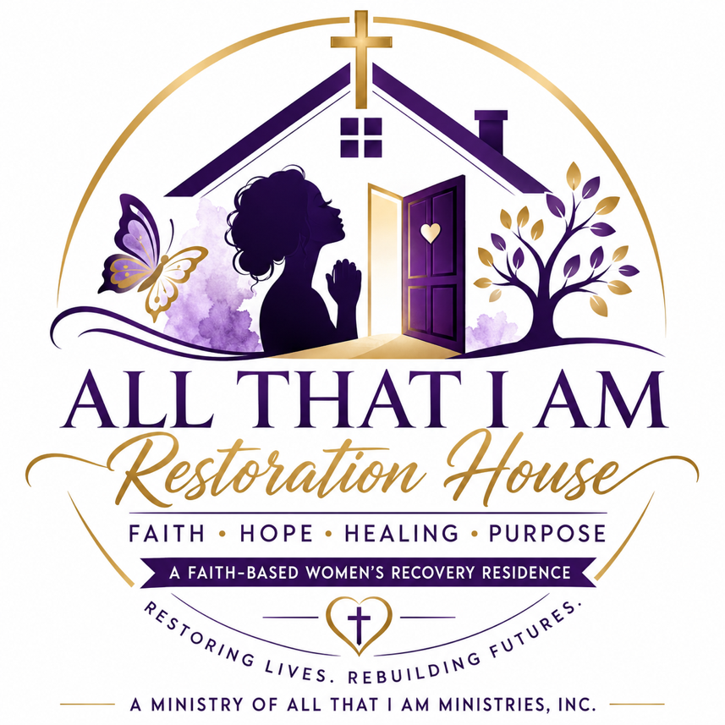
ALL THAT I AM RESTORATION HOUSE
Resident Handbook
A Faith-Based Women’s Recovery Residence
A Ministry of All That I Am Ministries, Inc.

WELCOME LETTER
Welcome to All That I Am Restoration House.
We are honored that you have chosen to begin or continue your journey of recovery, restoration, and rebuilding here. This home was created to provide women with a safe, structured, faith-based environment where healing, accountability, discipline, and purpose can grow.
This is not just a place to live. This is a place to be restored.
Our goal is to help each resident move from crisis to stability, from survival to purpose, and from brokenness to wholeness through faith, recovery support, personal responsibility, mentorship, and community.
By entering this home, you agree to respect the rules, honor the other residents, participate in the program, and commit yourself to a drug-free and alcohol-free lifestyle.
We believe your life has value. We believe your story is not over. We believe restoration is possible.

MISSION STATEMENT
All That I Am Restoration House exists to provide safe, structured, faith-based housing and recovery support for women seeking freedom from addiction, incarceration, homelessness, and life-controlling challenges.
Through biblical discipleship, accountability, mentorship, life-skills development, and community support, we empower women to restore their lives, rebuild their families, and discover their God-given purpose.

VISION STATEMENT
Our vision is to see women transformed through the power of Jesus Christ, restored to healthy relationships, equipped for independent living, and empowered to become productive leaders within their families, churches, and communities.

PROGRAM DESCRIPTION
All That I Am Restoration House is a faith-based recovery residence operated by All That I Am Ministries, Inc.
The program provides structured housing and recovery support for women who desire to live free from drugs, alcohol, destructive patterns, and unstable living conditions.
The program may include:
- Safe housing
- Prayer and biblical encouragement
- Recovery support
- Mentorship
- Life skills training
- Employment readiness
- Financial literacy
- Reentry support
- Transportation assistance when available
- Case management referrals
- Community resource connections
- Accountability and structure
All That I Am Restoration House is not a medical detox facility, hospital, psychiatric facility, or licensed clinical treatment center. Residents needing medical detox, inpatient psychiatric care, or nursing care may be referred to an appropriate provider.

STATEMENT OF FAITH
All That I Am Restoration House is a Christian faith-based ministry.
We believe:
- The Bible is the inspired Word of God.
- Jesus Christ is Lord and Savior.
- Prayer is essential to healing and spiritual growth.
- Every person has value, dignity, and purpose.
- Recovery and restoration are possible through faith, accountability, support, and personal responsibility.
- God can restore every area of a person’s life.
Residents are expected to respect the faith-based environment of the home.

RESIDENT RIGHTS
Every resident has the right to:
- Be treated with dignity and respect.
- Live in a safe and drug-free environment.
- Be free from abuse, neglect, harassment, and exploitation.
- Submit grievances without fear of retaliation.
- Have personal information kept confidential, except when disclosure is required by law or safety concerns.
- Receive fair and consistent treatment.
- Participate in program activities.
- Be informed of house rules and expectations.
- Practice her faith respectfully.
- Be heard when concerns arise.

NON-DISCRIMINATION POLICY
All That I Am Restoration House does not discriminate on the basis of race, color, national origin, age, disability, or any other legally protected status.
Residents are expected to treat one another with respect at all times.

ADMISSION REQUIREMENTS
Applicants may be accepted into the program if they:
- Are female and at least 18 years old
- Desire a sober and drug-free lifestyle
- Agree to follow all house rules
- Are willing to participate in program activities
- Are able to live independently without nursing care
- Do not pose a safety threat to themselves or others
- Complete the application and intake process
- Sign all required forms
Admission is not guaranteed. The Program Director or approved leadership will make final admission decisions.

REASONS ADMISSION MAY BE DENIED
Admission may be denied if the applicant:
- Is currently under the influence of drugs or alcohol
- Requires medical detox
- Requires inpatient psychiatric treatment
- Requires nursing home level care
- Refuses to follow program requirements
- Has violent behavior that may place others at risk
- Provides false information during the application process

RESIDENT RESPONSIBILITIES
Each resident is responsible for:
- Maintaining sobriety.
- Following all house rules.
- Respecting staff, volunteers, and other residents.
- Attending required meetings and activities.
- Keeping her room and shared spaces clean.
- Participating in assigned chores.
- Respecting confidentiality.
- Reporting safety concerns.
- Working toward employment, education, or approved service.
- Participating in her recovery and restoration plan.

HOUSE RULES
Residents must follow these basic house rules:
- No drugs or alcohol.
- No possession of illegal substances.
- No violence, threats, bullying, or intimidation.
- No stealing.
- No weapons.
- No overnight guests.
- No sexual activity inside the residence.
- No smoking inside the home.
- No disrespect toward staff, volunteers, or residents.
- No leaving the home overnight without approval.
- No bringing unapproved visitors into the home.
- No loud music, yelling, or disruptive behavior.
- Rooms and common areas must be kept clean.
- Curfew must be followed.
- Residents must participate in chores and house meetings.
- Residents must submit to drug or alcohol testing when requested.
- Residents must follow medication storage policies.
- Residents must respect the faith-based environment.
Violation of house rules may result in corrective action, probation, suspension of privileges, or discharge.

DRUG AND ALCOHOL-FREE POLICY
All That I Am Restoration House is a drug-free and alcohol-free residence.
Residents may not possess, use, distribute, or be under the influence of:
- Illegal drugs
- Alcohol
- Unauthorized prescription medication
- Marijuana
- Drug paraphernalia
- Any substance used for intoxication
Residents may be required to submit to random drug and alcohol screening. Refusal to test may be treated as a positive result.
A positive test may result in corrective action, increased accountability, referral to treatment, or discharge depending on the situation.

CURFEW POLICY
Curfew exists for safety, accountability, and structure.
Standard curfew:
Sunday through Thursday: 9:00 PM
Friday and Saturday: 10:00 PM
Unemployed residents or residents in early program phases may have an earlier curfew.
Work-related exceptions must be approved by staff. Residents who are delayed must contact staff immediately.
Repeated curfew violations may result in corrective action.

SIGN-IN AND SIGN-OUT POLICY
Residents must sign out when leaving the residence and sign back in upon return.
The sign-out log must include:
- Date
- Time out
- Destination
- Expected return time
- Actual return time
Residents may not leave for unapproved locations.

VISITOR POLICY
Visitors are allowed only during approved visiting hours and must be approved by staff.
Visitors must:
- Sign in and out
- Remain in approved areas
- Respect house rules
- Leave when directed by staff
Visitors may not bring drugs, alcohol, weapons, or disruptive behavior into the home.
Overnight visitors are not allowed.
Staff may deny or remove any visitor who creates a safety concern.

CHORE POLICY
Each resident is responsible for helping maintain the home.
Chores may include:
- Cleaning bathrooms
- Cleaning kitchen
- Sweeping and mopping
- Taking out trash
- Washing dishes
- Cleaning common areas
- Laundry area upkeep
- Yard cleanup
A weekly chore schedule may be posted. Failure to complete chores may result in corrective action.

ROOM CLEANLINESS POLICY
Residents must keep bedrooms clean and orderly.
Residents are expected to:
- Make beds daily
- Keep floors clear
- Put clothes away
- Remove trash
- Keep food out of bedrooms unless approved
- Maintain personal hygiene
- Respect shared space
Rooms may be inspected by staff for cleanliness, safety, and contraband.

PERSONAL PROPERTY POLICY
Residents are responsible for their own personal belongings.
All That I Am Restoration House is not responsible for lost, stolen, or damaged personal property unless required by law.
Residents should not bring expensive jewelry, large amounts of cash, or unnecessary valuables into the home.
Upon discharge, residents must remove personal belongings within the time given by staff. Items left behind may be handled according to program policy.

MEDICATION POLICY
Residents are responsible for taking their medications as prescribed.
All medications must be reported during intake.
Medication may be required to be stored in a secure location depending on house policy.
Residents may not share, sell, trade, or misuse medication.
Prescription medication must remain in the original container with the resident’s name and prescribing information.
Misuse of medication may result in corrective action or discharge.

MEDICAL EMERGENCY POLICY
In the event of a medical emergency, staff may call 911.
Residents must report serious illness, injury, or medical concerns to staff.
Emergency contacts may be notified when necessary.
All medical emergencies will be documented with an incident report.

FAITH-BASED PROGRAMMING
Residents are expected to respect the Christian foundation of the home.
Faith-based programming may include:
- Prayer
- Bible study
- Devotion
- Church attendance
- Spiritual mentoring
- Worship services
- Christian life-skills teaching
Residents are expected to participate respectfully in required program activities.

RECOVERY SUPPORT
Residents are expected to actively participate in their recovery.
Recovery support may include:
- House meetings
- Peer support
- Mentorship
- Recovery groups
- Accountability check-ins
- Individual goal planning
- Referrals to outside counseling or treatment services
Residents needing clinical treatment may be referred to licensed providers.

EMPLOYMENT AND JOB SEARCH POLICY
Residents who are physically and mentally able are expected to work, attend school, participate in training, volunteer, or actively seek employment.
Residents seeking employment may be required to:
- Complete job applications
- Attend interviews
- Submit job search logs
- Participate in employment readiness activities
- Maintain appropriate work behavior
Employment is an important part of rebuilding stability and independence.

FINANCIAL RESPONSIBILITY
Residents are encouraged to manage money responsibly.
Residents may receive support with:
- Budgeting
- Saving money
- Paying program fees
- Opening a bank account
- Planning for housing
- Paying fines or legal obligations
- Preparing for independent living
Residents are encouraged to save toward permanent housing and long-term stability.

TRANSPORTATION POLICY
Transportation may be provided when available for approved purposes, including:
- Work
- Medical appointments
- Court appearances
- Recovery meetings
- Church services
- Job interviews
- Approved community services
Transportation is not guaranteed and depends on staff availability, scheduling, and program resources.
Residents should provide advance notice when transportation is needed.

COURT, PROBATION, AND PAROLE REQUIREMENTS
Residents involved with court, probation, or parole must comply with all legal requirements.
Residents may be required to provide:
- Probation officer contact information
- Court dates
- Required appointments
- Documentation of compliance
Failure to follow legal requirements may result in discharge or referral to the appropriate authority.

CONFIDENTIALITY POLICY
Residents must respect the privacy of others.
Residents may not share another resident’s personal story, legal situation, recovery history, family matters, or private information outside the home.
Staff and volunteers are also required to protect resident confidentiality, except when disclosure is required by law, safety concerns, emergency situations, or signed consent.

GRIEVANCE PROCEDURE
Residents have the right to submit concerns or complaints.
Steps:
- Speak with staff if appropriate.
- Submit a written grievance.
- The Program Director will review the grievance.
- A response will be provided within a reasonable time.
- If needed, the matter may be reviewed by higher leadership or the Board.
No resident will be punished for filing a good-faith grievance.

INCIDENT REPORTING
Residents must immediately report:
- Injuries
- Threats
- Violence
- Drug or alcohol use
- Theft
- Property damage
- Medical emergencies
- Fire or safety hazards
- Police involvement
- Missing resident concerns
Staff will complete an incident report when required.

SAFETY RULES
Residents must help keep the home safe.
Residents may not:
- Block exits
- Tamper with smoke detectors
- Disable cameras or safety equipment
- Bring weapons into the home
- Start fires or burn candles without approval
- Use appliances improperly
- Allow unauthorized persons inside
- Ignore emergency instructions
Safety violations are taken seriously.

FIRE SAFETY PLAN
In case of fire:
- Leave the building immediately.
- Do not stop to gather belongings.
- Alert others if safe to do so.
- Go to the designated meeting place.
- Call 911.
- Do not re-enter the building until emergency officials say it is safe.
Fire drills may be conducted.

TORNADO SAFETY PLAN
During a tornado warning:
- Go to the designated shelter area.
- Stay away from windows.
- Sit low and protect your head.
- Remain in place until the warning has passed.
- Follow staff instructions.
Residents should know the designated shelter area upon admission.

EMERGENCY CONTACTS
Residents must provide current emergency contact information.
Residents must notify staff if emergency contacts change.
Emergency contacts may be contacted in the event of:
- Medical emergency
- Safety concern
- Discharge emergency
- Missing resident situation
- Serious incident

PROHIBITED ITEMS
The following items are not allowed:
- Drugs
- Alcohol
- Weapons
- Drug paraphernalia
- Stolen property
- Pornographic materials
- Unauthorized medication
- Open flames or candles
- Items that create safety hazards
- Any item staff determines threatens safety or recovery
Prohibited items may be removed by staff.

SEARCH POLICY
To maintain safety and sobriety, staff may inspect rooms, common areas, bags, or personal belongings when there is reasonable concern or as part of routine safety checks.
Searches will be conducted respectfully.
Refusal to cooperate may result in corrective action.

DISCIPLINARY ACTION
Corrective action may include:
- Verbal warning
- Written warning
- Loss of privileges
- Increased accountability
- Program probation
- Required meeting with staff
- Referral to outside services
- Discharge
The level of discipline will depend on the seriousness of the situation.

IMMEDIATE DISCHARGE
A resident may be immediately discharged for:
- Violence or threats
- Drug or alcohol use
- Possession of weapons
- Theft
- Bringing drugs into the home
- Endangering others
- Serious disrespect or disruption
- Refusal to follow safety instructions
- Illegal activity
- Repeated rule violations
Immediate discharge decisions are made to protect the safety and stability of the home.

VOLUNTARY DISCHARGE
Residents may choose to leave the program voluntarily.
Residents are encouraged to speak with staff before leaving so a safe exit plan can be discussed.
Staff may assist with referrals when appropriate.

PROGRAM COMPLETION
Residents may complete the program when they have demonstrated:
- Sobriety and stability
- Compliance with house rules
- Participation in program activities
- Employment, school, training, or approved service
- Progress toward personal goals
- A safe housing plan
- Financial responsibility
- Continued recovery support plan
Completion may be recognized with a certificate or graduation ceremony.

RESIDENT ACKNOWLEDGMENT
I acknowledge that I have received and reviewed the All That I Am Restoration House Resident Handbook.
I understand that I am responsible for following the rules, policies, and expectations of the program.
I understand that failure to follow the rules may result in corrective action or discharge.
Resident Name: ______________________________________
Resident Signature: __________________________________
Date: ______________________________________________
Staff Witness: _______________________________________
Date: ______________________________________________

EMERGENCY NUMBERS
Police / Fire / Ambulance: 911
Program Director: ___________________________________
House Manager: _____________________________________
Emergency Contact: __________________________________
Nearest Hospital: ____________________________________
Poison Control: _____________________________________

FINAL STATEMENT
All That I Am Restoration House exists to help women rebuild their lives in a safe, structured, faith-based environment.
This home is built on faith, accountability, respect, responsibility, and restoration.
Every resident is expected to do her part to protect the peace, safety, and purpose of the home.
Your past does not disqualify you from your future.
Restoration starts here.

